Pop-a-Note: How to Import Contacts and Group

As you may have noticed Pop-a-Note works by sending Notes to groups of your contacts. You don’t need to use the “My Groups” feature but some users find they want to send different notes to different contacts so they organize their contacts into groups.

You can name a group anything you want; for example maybe you have contacts that previously bought a home from you, you could create a group called “Past Clients” and assign these contacts to the “Past Clients” group. Or maybe you have a list of contacts that you are working with currently; you could create another group called “Current Prospects,” and again name the group whatever you like. This feature is for your organizational purposes only.

If you are importing a large list of contacts you might want to consider assigning them to a Group as you import them. Doing this will group them all at once. (The alternative would be to manually assign a contact to a group after they are imported, which takes a bit more time.)

To place your contacts into a Group(s) as they are imported follow these steps:

Go to Contacts > My Groups and click “Add Group.”
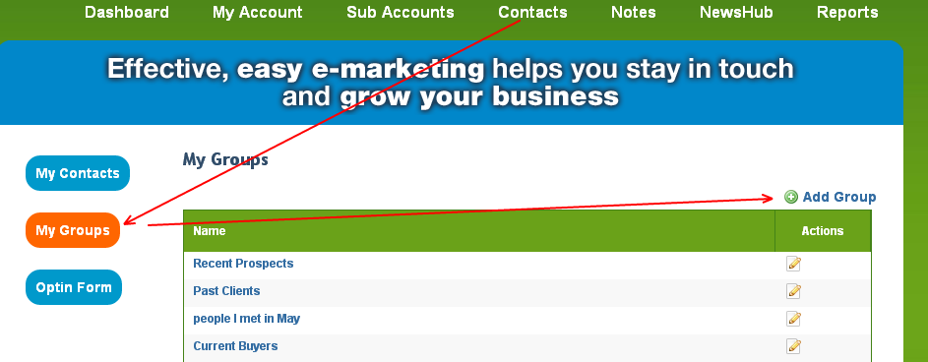

Enter your Group name and click Save. (HINT Remember exactly what you named this group! You will need to type it exactly into your CSV file later on.) You can create as many Groups as you want; just be sure to remember exactly what the Group names are. This will be important later. (“Current Prospects” is not the same as “CurrentProspect.”)
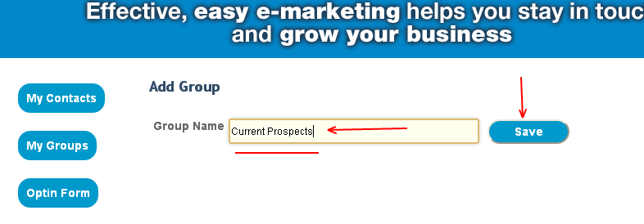

continued...

Next go to Contacts > My Contacts and click “Import Contacts.”

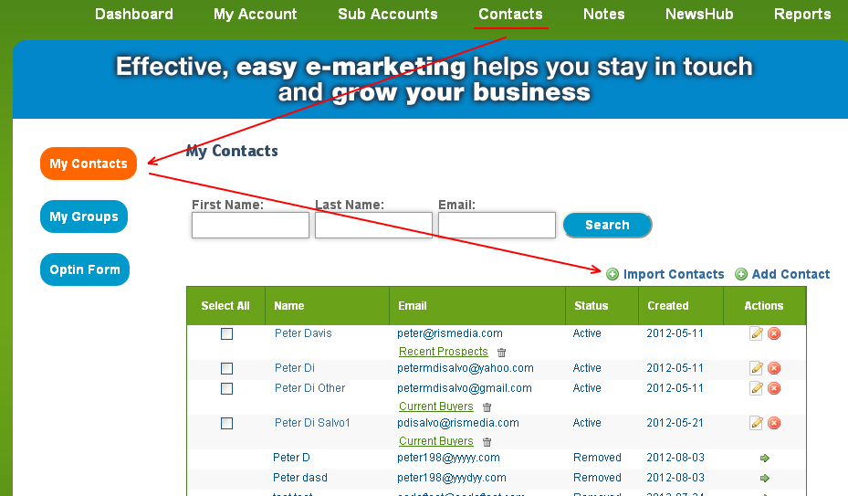

EXPORT a CSV file of your contacts from other email systems or other customer relationship management systems. (We have provided instructions for email MS Outlook, Gmail, and Yahoo!)

Next, open your spreadsheet.
Note that column order does not matter, each software will have columns in different orders and the column names will be different - that is OK, proceed...
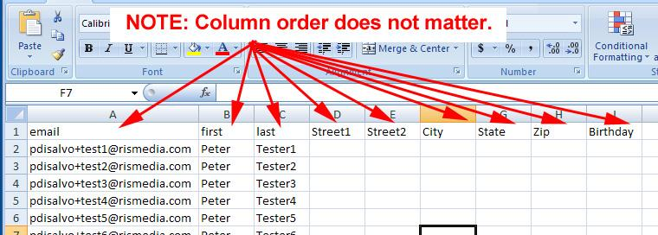

continued...

Insert a new column to your spreadsheet and call it “Group.”
It doesn't matter where the column is located.
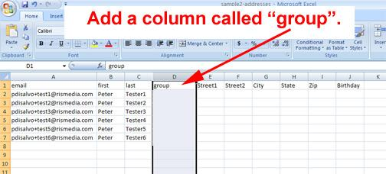

Type or paste the group name to each contact respectively.
The group name that you type here must be exactly the same group name that you created in your Pop-a-Note. “My Group” area. For example if you created “Current Prospects” in Pop-a-Note, then type or copy and paste the “Current Prospects” label near the client name. You can import clients to different Groups at the same time, as long as 1) that group exists in Pop-a-Note, and 2) as long as you use the exact same name.

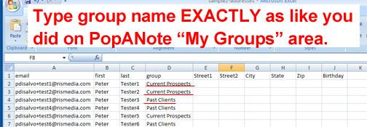

Be sure to save your changes, and be sure to “Save As” a .CSV file!

continued...

Now import your contacts.
If you have not already done so login to your PopANote.com account and go to Contacts > My Contacts. Click “Import Contacts.”
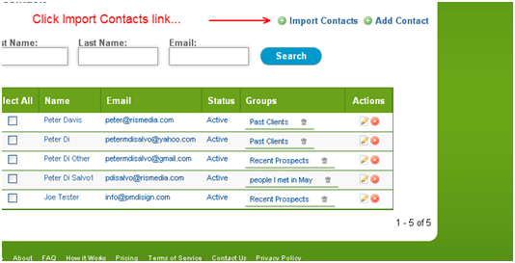

Browse to the CSV file, select it and click Open from Windows Explorer.
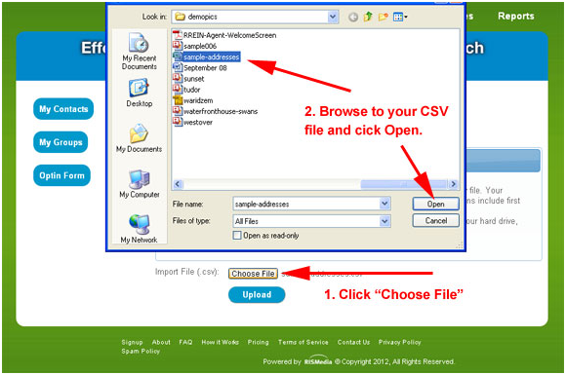

continued...

Click “Upload” and you will start to see the first few rows. Use the Ignore First to avoid importing the header row. Using the drop down menus, label the corresponding columns First Name, Last Name, Email Address and Group.
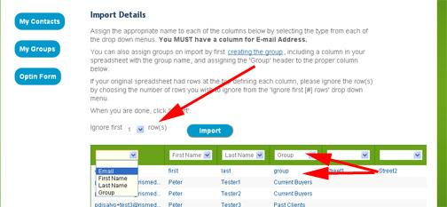

TIP: Depending on your spreadsheet layout, you may need to use the scroll bar in bottom of window to scroll to the right or left to find the first, last, email, or group column.

continued...

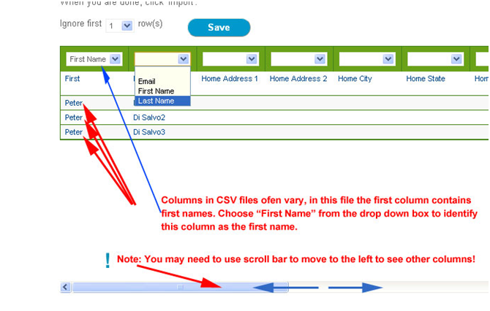

Tip: Skip the columns you don’t need – just leave the selector blank.
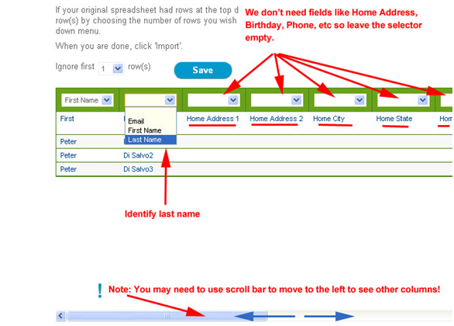
continued...

Once first, last, email, and group have been identified, click “Import” to add these names to your Contact list:
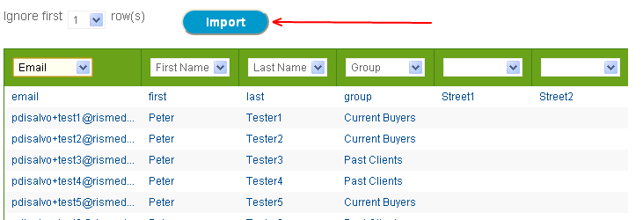

Done! Now you can go to “My Contacts” to see your contacts added and assigned to these groups.

