Pop-a-Note: How to Import a CSV file into Pop-a-Note:
Login to PopANote.com, Go to Contacts tab, click “Import Contacts”:
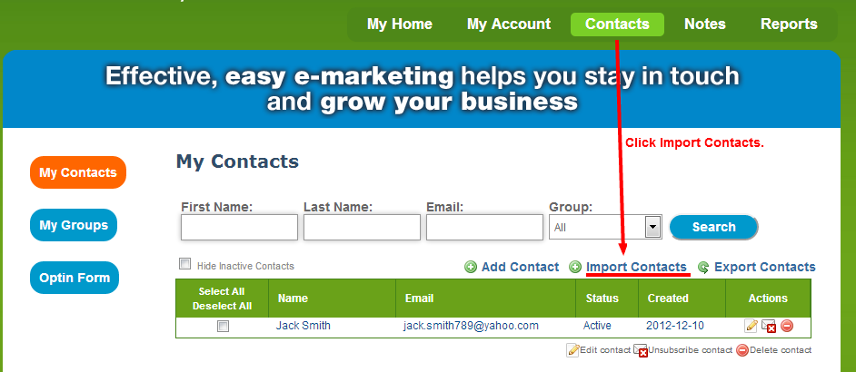

You will arrive at “Import Contacts Window.” Click “Choose File” button:
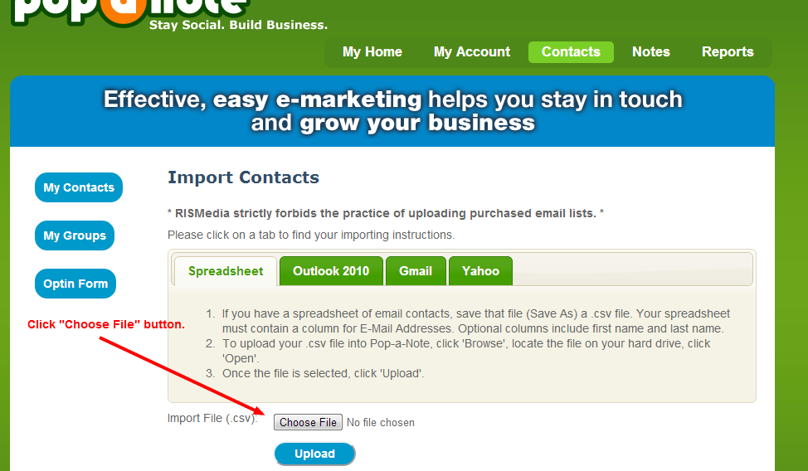

- Browse to the CSV file that you exported from your mail or customer service software.
- Select file by clicking it so it highlights.
- Click Open from Windows explorer.

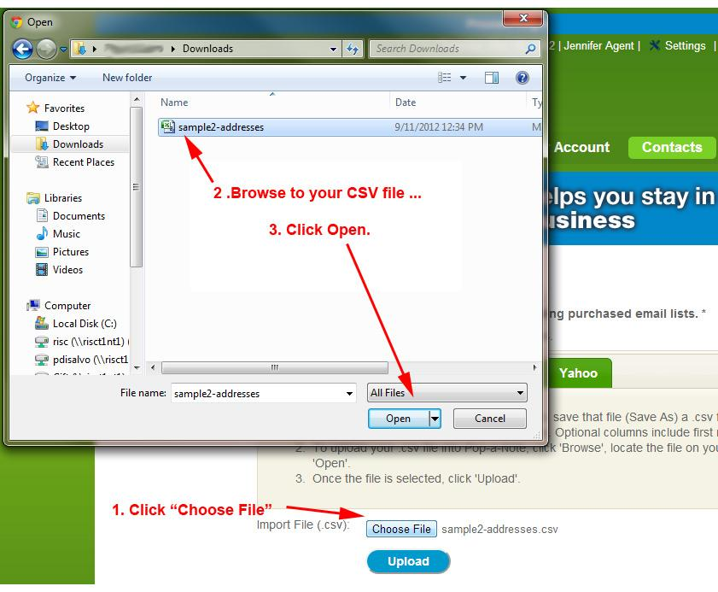
- Click “Upload” and you will start to see the first few rows appear.
- Use the Ignore First to avoid importing the header row if your file has descriptions or titles in the first row as headers over each column.

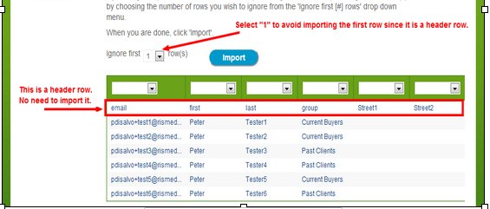

- Identify the First Name, Last Name and the Email address of client.
- If client has more than one email address be sure to only select ONE column.

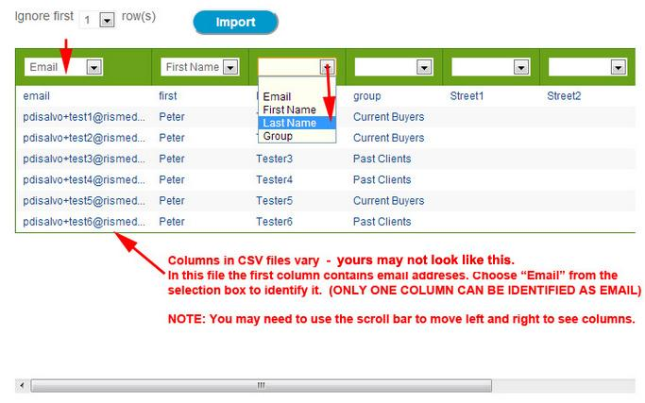
Hint: You may need to use the scroll bar in bottom of window to scroll to the right or left to find the first, last, or email column.
Hint: Skip the columns that you do not need – just leave the selector blank.
(Continued)

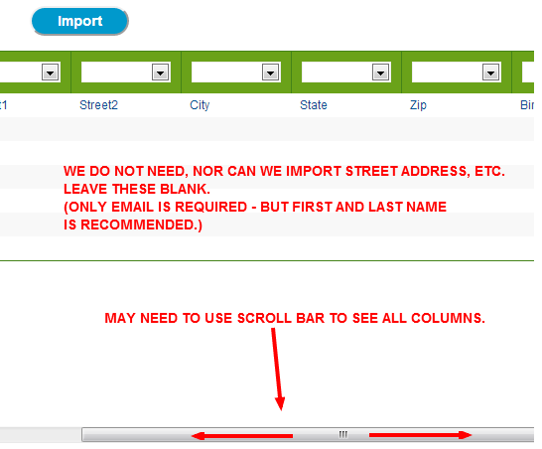
When all fields are identified click “Import.”
Pop-a-Note will de-duplicate during import. Contacts will not be added twice. You can import another list in the future without fear of adding a contact twice.
